Software Automation Engineering Team

Desk Procedure for Setting Up SSH Keys on IPWIN Servers (powershell version 2016):

Document Owner: Richard M. Williams

Editor: Richard M. Williams
Document name: Desk Procedure for Setting Up SSH Keys on the IPWIN Servers – version 2016.doc
Document Revision Number: 8-21-19
Document Status: Complete

Desk Procedure for Setting Up SSH Keys on the IPWIN Servers:

- On the ipwin boxes ensure the “Powershell Server 2016” service is running:
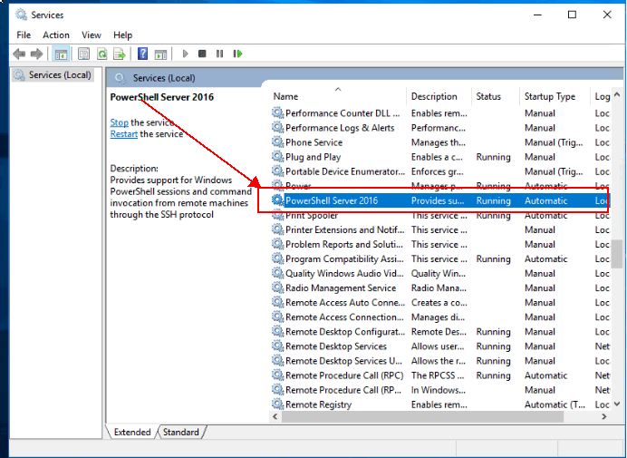

- On the ipwin boxes, open up Powershell as an administrator and run the following command
“winrm quickconfig”. Ensure that powershell is enabled for remote management:
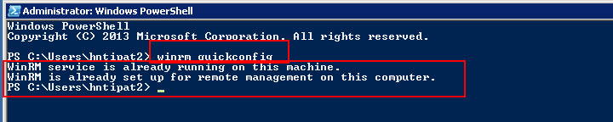

- Test remote powershell commands between (to\from) the ipwin servers and some sample target servers:
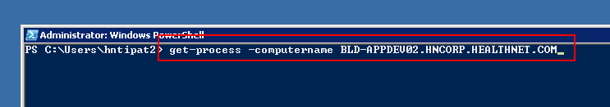
- As previously noted, each Windows (IPWIN) jumpbox should have an application service called “Powershell Server 2016”. If you double-click on that service, you will see the full path for the executable file (if you need it):
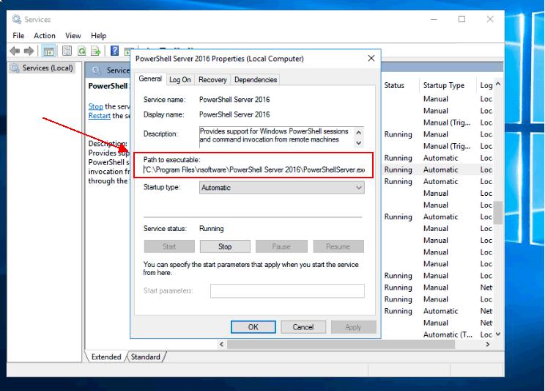

- Next, launch the “START POWERSHELL SERVER 2016” as depicted below:
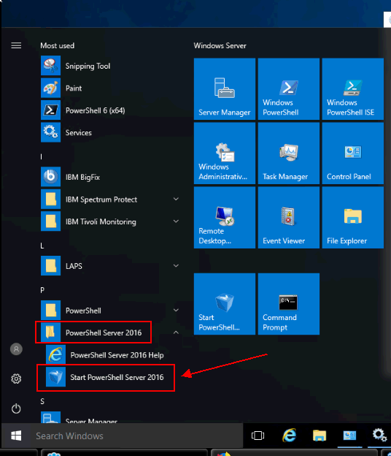

- Next, click on the various tabs and ensure all settings are accurate. Start with the SERVICE tab and ensure the “Run as a Windows Service” box is checked \ enabled:
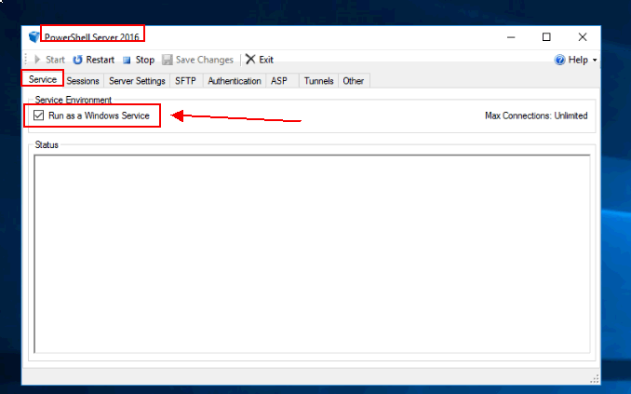

- Next, click on the SESSIONS tab and ensure its configured as illustrated below:
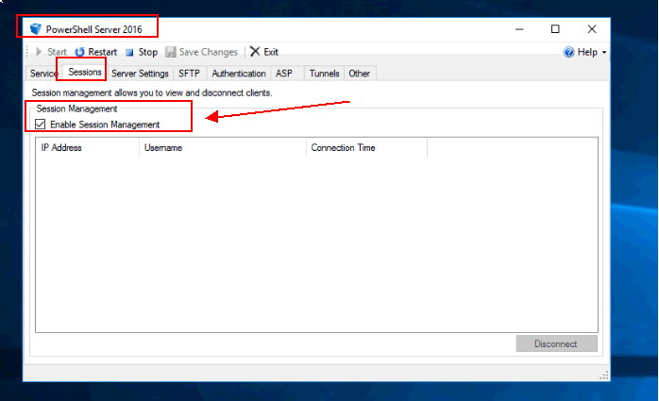

- Next, click on the SERVER SETTINGS tab and ensure the following settings are in place. These should be the defaults settings but just validate all looks okay:
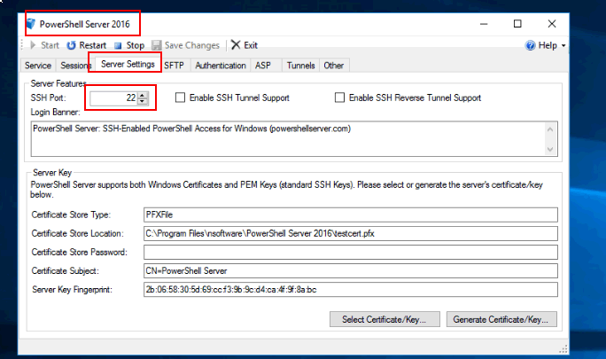

- Next, check the SFTP tab and ensure the following default settings are in place. No changes “should” be required here but just validate for accuracy:
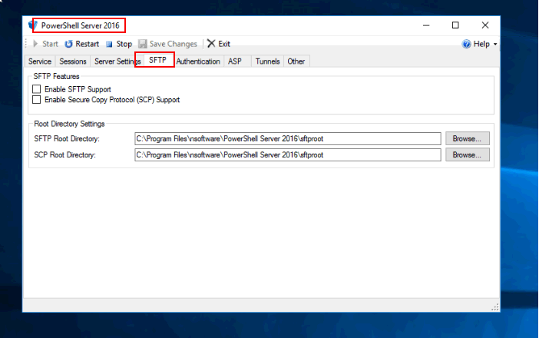

- Next, configure the AUTHENTICATION tab as depicted below. Be sure to map to the SSH KEY file as depicted in the last red box below. You can rename the file to sshkey.txt if you like:
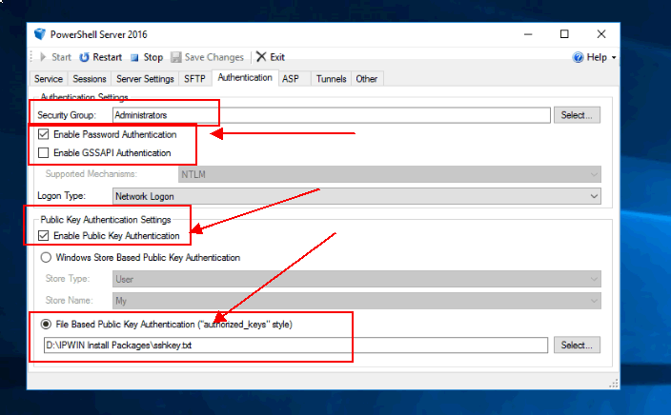

- Next, check your ASP tab and ensure it looks like the following tab:
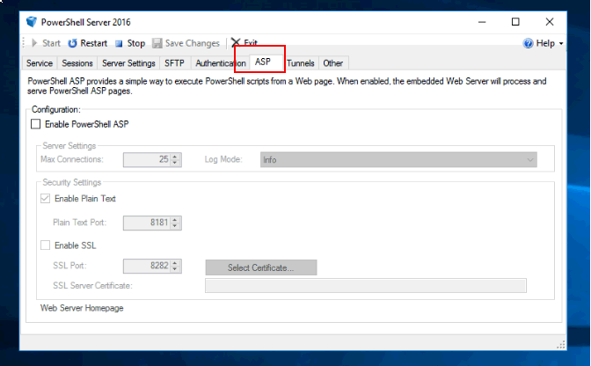

- Next, check the TUNNELS tab. Again the default settings should apply here:
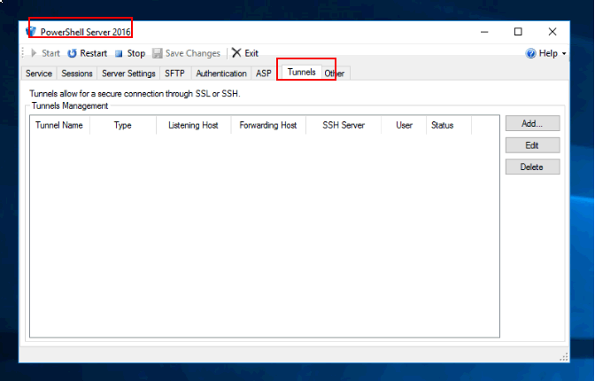

- Next, check the OTHER tab and ensure its setup accordingly:
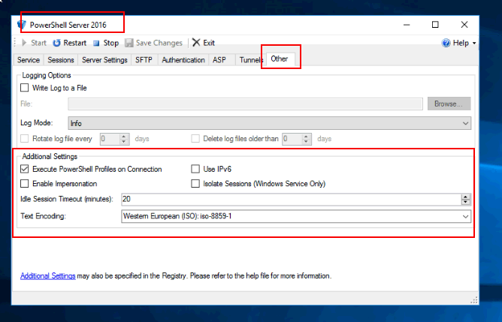

- Now, click the SAVE CHANGES button:
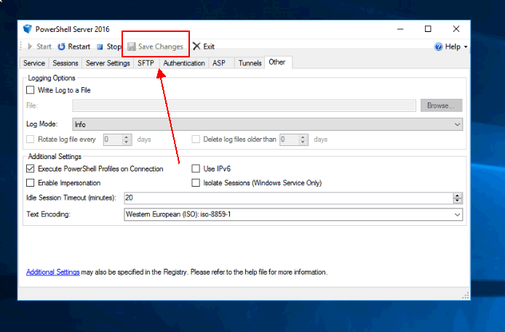
- Click the STOP Button:
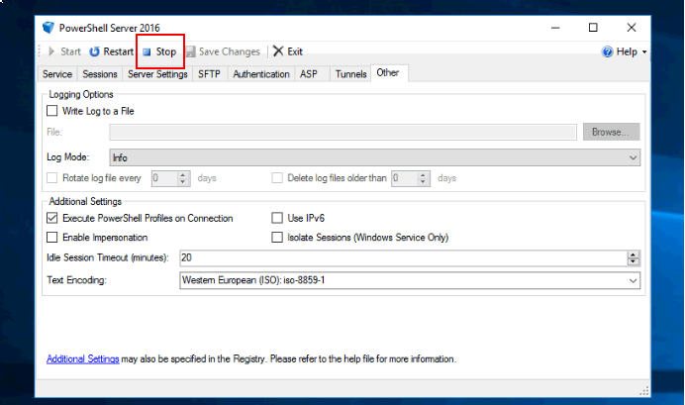
- Click the START Button:
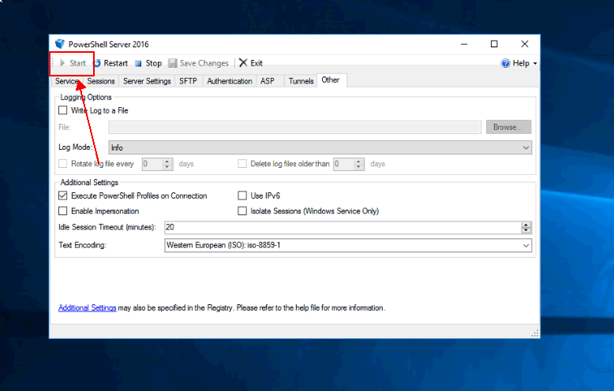
- Have a Dynamic Automation CSI contact check and ensure that DA can communicate with your new IPWIN Server(s).

